111學年度第二學期 基隆市立中山高級中學 國中一年級英語科 第一次段考試題
年 班 座號： 姓名：
選擇題分數:
非選題分數:
總分:

選擇題部份: (1-35題)總共70分
聽力測驗
- 辨識句意：每題均有三張圖片，請依據所聽到的句子，選出符合描述的圖片。（每題2分，共10分）
  - ( )
    - 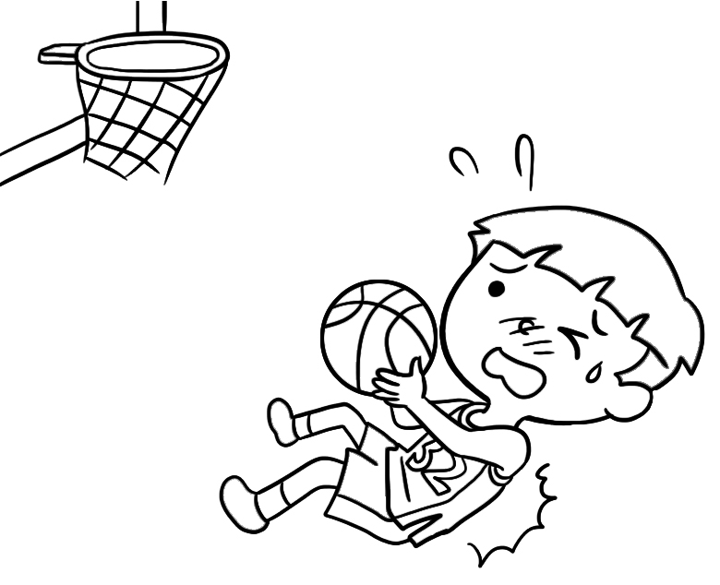 (B) 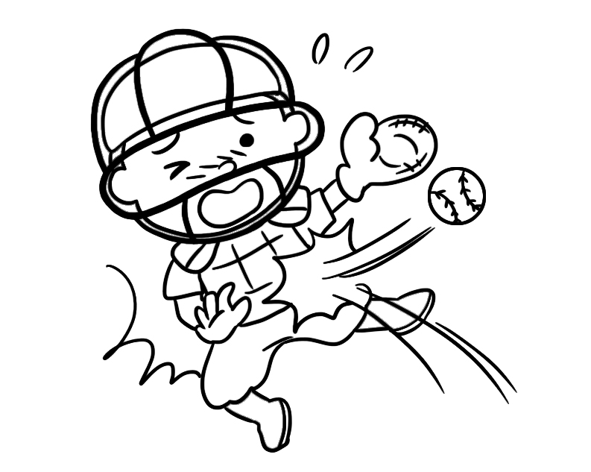 (C) 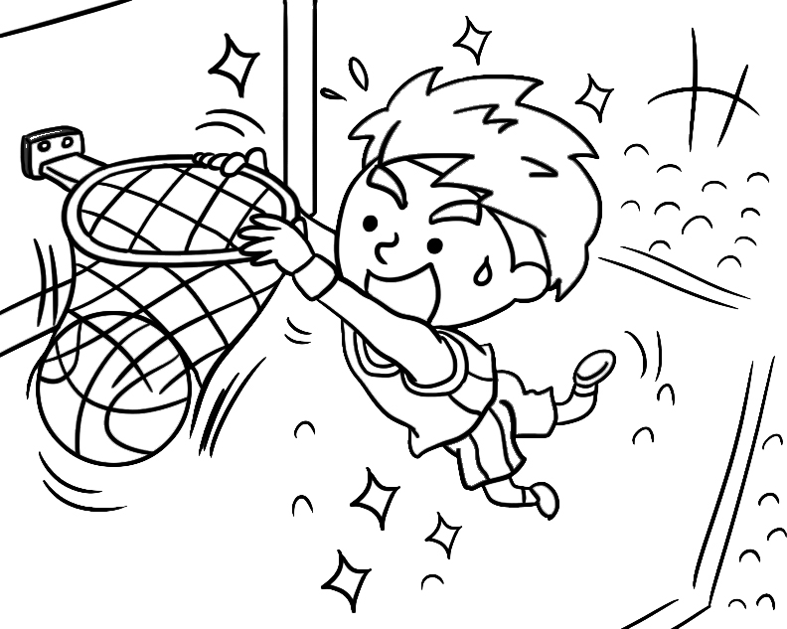
  - ( )
    - 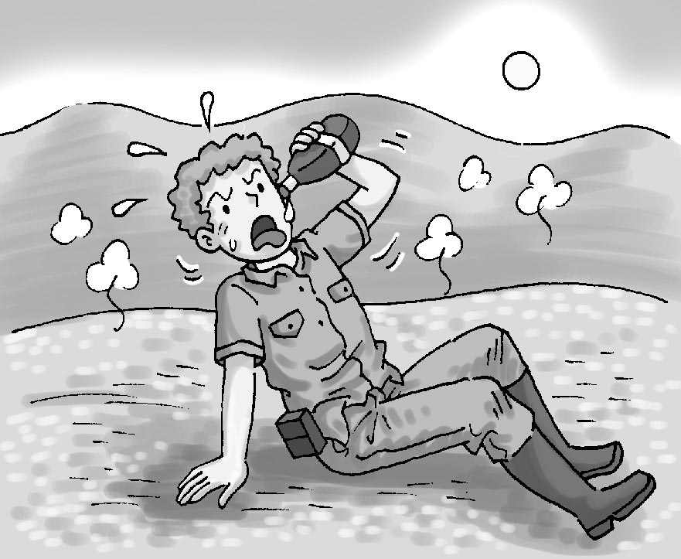 (B) 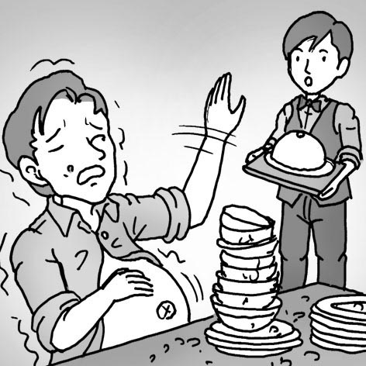 (C) 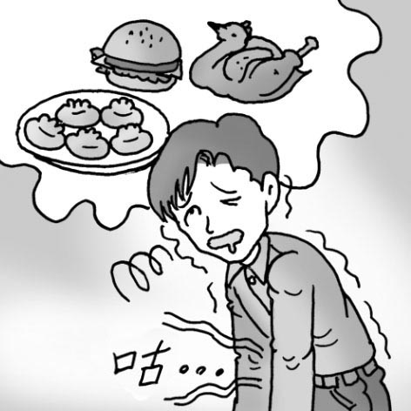
  - ( )
(A) 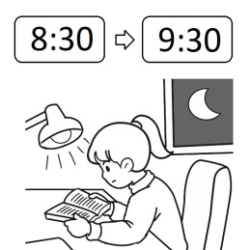 (B) 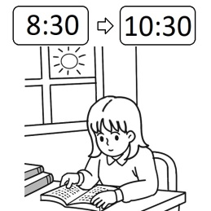 (C) 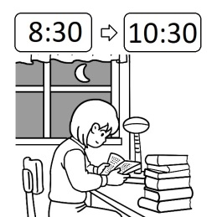
  - ( )
    - 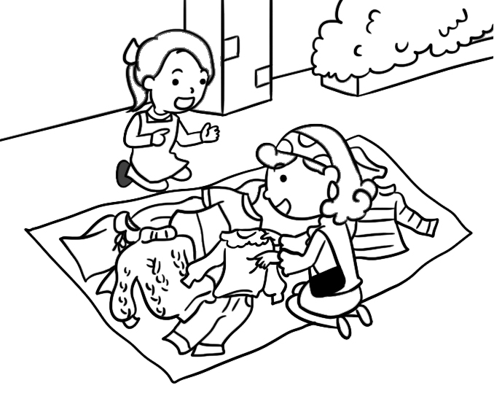 (B) 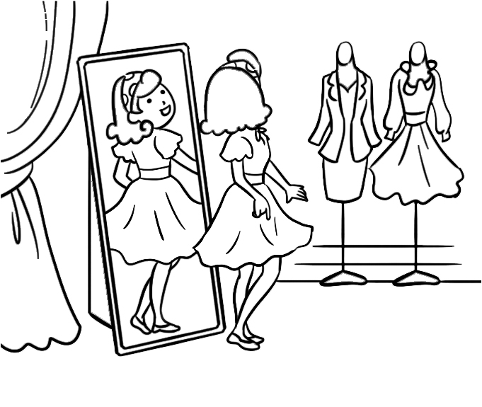 (C) 
  - ( )
    -  (B) 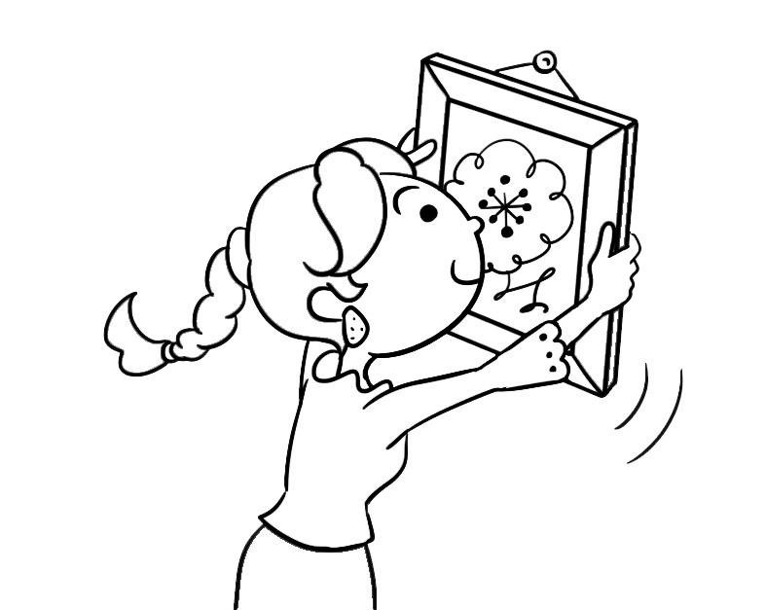 (C) 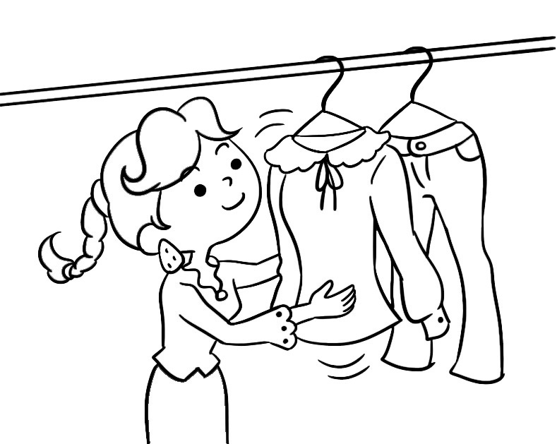

- 基本問答：每題均有三個選項，請依據所聽到的內容，選出一個最適合的回應。（每題2分，共6分）
6. ( ) (A) They study from two to three. (B) It’s five thirty now. (C) They study hard.
7. ( ) (A) They are my favorite fruit. (B) They are one hundred and fifty dollars. (C) I have a lot of them.
8. ( ) (A) So, it’s not possible to touch rhinos in the zoo?
(B) Really? How much is the ticket for the game?
(C) That’s great! I can’t wait to see them.
三、言談理解：每題均有三個選項，請依據所聽到的對話與問題，選出一個最適當的答案。（每題2分，共4分）
9. ( ) (A) (A) They want to play video games.
(B) They want to study with their brother.
(C) They want to go out with their parents.
10. ( ) (A) They are classmates. (B) They don’t like the class. (C) They are sharing a book.

單題測驗
四、文法選擇（每題2分，共20分）
11.( ) A：Do you like watching basketball games on TV? B：No, I ＿＿＿, but my brothers ＿＿＿. They love basketball.
(A) don’t; don’t (B) do; do (C) don’t; do (D) do; don’t
12.( ) A：＿＿＿ is your new pen? B：It’s 35 NT dollars.
(A) What (B) What much (C) How (D) How much
13.( ) I can’t play baseball, and my brother, Sam, ＿＿＿ play baseball, either.
(A) can (B) can’t (C) does (D) doesn’t
14.( ) A：What ______ Mr. and Mrs. Huang do on Sundays? B：They play badminton with friends.
(A) do (B) does (C) can (D) are
15.( ) A：I can’t play soccer. ＿＿＿ you? B：Sure. It’s not hard for me.
(A) Can’t (B) Are (C) Can (D) Must
16.( ) A：Can your sister play the piano? B：No, she ＿＿＿. But she can play the guitar (吉他).
(A) can (B) can’t (C) is (D) isn’t
17.( ) Everyone in my club ＿＿＿ play baseball. We like to watch baseball games together.
(A) are (B) can (C) ╳ (D) is
18.( ) Practice hard, and you can ＿＿＿ a good badminton player.
(A) are (B) do (C) be (D) ╳
19.( ) A：＿＿＿ you like banana? B：Yes. I like them.
(A) Don’t (B) Aren’t (C) Isn’t (D) Not
20.( ) A：My husband, Larry, ＿＿＿ take care of his one-year-old son.
B：My husband, Hank, ＿＿＿, either. He doesn’t think it’s his duty(責任).
(A) helps; does (B) helps; helps (C) doesn’t help; does (D) doesn’t help; doesn’t
五、克漏字選擇（每題2分，共10分）

(Steve is a good boy, ＿21.＿ he can’t get good grades at school. His father, Mr. Lee, is not very happy about this. Mr. Lee is a doctor, and he wants his son to be a doctor, too. Now Mr. and Mrs. Lee are talking about this problem.)
Mr. Lee：Take a look at Steve’s test grades. ＿22.＿
Mrs. Lee：Come on. Give him a break.
Mr. Lee：No way. This is a big problem.
Mrs. Lee：Learning is not only for grades. And you don’t really know him.
Mr. Lee：＿23.＿ How can I not know my son?
Mrs. Lee : First, he doesn’t want to be a doctor. Besides, ＿24.＿, and he wants to be a soccer player. Do you know that?
Mr. Lee：I’m sorry. I’m busy every day and don’t have much time for him. Being a soccer player isn’t that bad. In fact, I like soccer, too. I can ＿25.＿ him and ＿25.＿ fun with him.
Mrs. Lee：Great! I’m happy to hear that.
 report 成績 learning 學習 first 首先 besides 此外 busy 忙碌的 hear 聽到
（ ）21. (A) and (B) but (C) so (D) for
（ ）22. (A) Life must be hard for our son.
(B) Doesn’t he study hard for the tests?
(C) He can practice soccer after school every day.
(D) Doesn’t he have time for video games?
（ ）23. (A) Where is he now?
(B) What do you mean?
(C) What time does he play soccer?
(D) How much time does he study for the test?
（ ）24. (A) he likes sports
(B) he loves animals
(C) his grades are good
(D) he doesn’t like sports
（ ）25. (A) teach; have
(B) teaches; have
(C) teaching; having
(D) to teach; to have
六、閱讀測驗（每題2分，共20分）
1.
The snake, the turtle, the dog, and the rabbit are classmates. They are in a happy animal school. Here are some facts about them.
 | 
My name is Stripy. I like everything but sports. I’m good at music. I can sing and dance. I sleep a lot on weekends. Look at me. I’m a little heavy but cute, right? | I’m Ninja. I like English. It’s my favorite subject at school. I study it at home, too. Now I am good at English. I can talk with other foreign turtles. I can’t run fast, but I can swim fast. I swim every morning. It’s fun!
 | 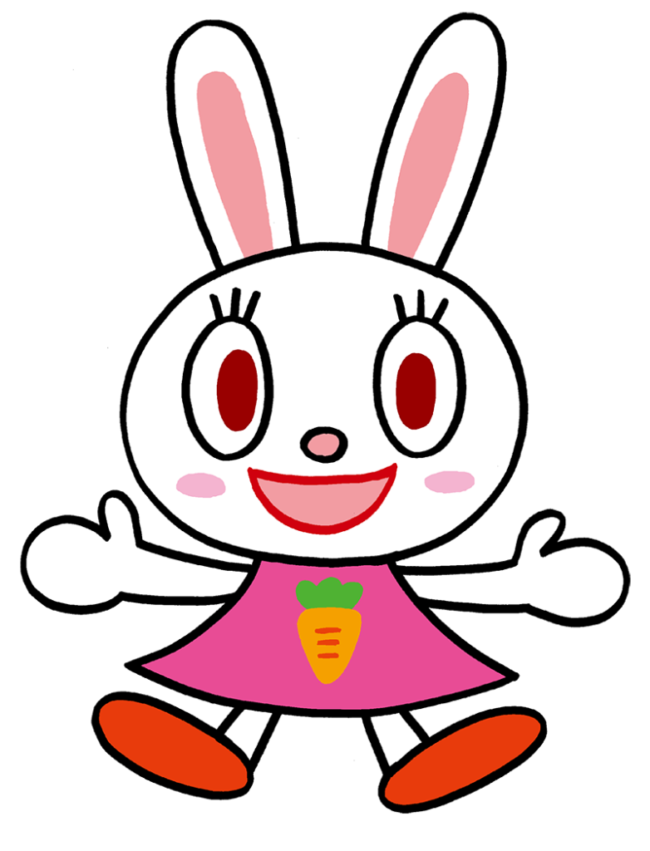
My name is Chobby. I like PE classes. I can run, jump, and play frisbee. Homework is difficult for me, but Stripy helps me with it after school every day. We often sing together. Stripy is really my good friend. | I’m Bunny. I am interested in every school subject. Tests are “a piece of cake” for me, and my grades are good. I often help my classmates and teach them. I really like my school.
 turtle 烏龜 music音樂 subject科目 fast快地 swim游泳 frisbee飛盤 be interested in 對…有興趣
26.( ) Who is not good at doing homework? (A) Stripy (B) Ninja (C)Chooby (D)Bunny
27.( ) Who does NOT like PE classes? (A) Stripy (B) Ninja (C)Chooby (D)Bunny
28.( ) What does “a piece of cake” mean? (A)Easy (B)Sad (C)Difficult (D)Terrible
29.( ) Which is true? (A) Stripy is tall and thin. (B) Ninja studies English only at school.
(C) Chobby’s classmate, Stripy, often sings with him. (D)Bunny doesn’t help her classmates.
2.
Harry：What do you do on Saturdays, Charlie?
Charlie：I watch basketball games on TV with my brother on Saturdays.
Harry：Do you want to come to the game when I play for our school?
Charlie：No way! Are you on the basketball school team?
Harry：Yes, and I have two tickets for the final next Saturday.
Charlie：Sure. It’s a big game!
Harry：Yes, it is. We will play at the National Stadium, so make sure you know the rules.
Charlie：What do you mean?
Harry：Here, check out the back of the tickets. It tells you what is not allowed in the stadium, like don’t bring your pets.
Charlie：Thanks! I will cheer for you!
 
 final 決賽 will 將會 back 背面 tell 告訴 bring 攜帶 cheer 歡呼
30.( ) Which is true?
(A) Charlie plays basketball on Saturdays.
(B) Charlie is on the school basketball team.
(C) Harry is a basketball player in his school.
(D) Harry and Charlie don’t like watching basketball games.
31.( ) What might the workers say at the stadium?  might 可能 worker 工作者
(A) “You can bring your pet to enjoy the game together.”  pet 寵物
(B) “You have to take off your baseball cap.”
(C) “You can’t use a camera to take pictures.”  camera 相機
(D) “You can’t bring food with you.”
32.( ) Charlie sees a sign on a door in the stadium. It says, “Visitors Are Not Allowed.” What does it mean?  visitor 訪客 mean 意指
(A) She can sit by this door.
(B) She can’t close this door.
(C) She can be in this room.
(D) She can’t go into the room.
33.( ). What can Charlie bring to the game?
(A) (B)
 
(C) (D)
 
3.
Do you sit at your desk for long hours? That is not good for you. Now, go out and play baseball with your friends. A lot of students play baseball. It can help their hand-eye coordination. That is, it helps their hands and their eyes work together better. Moreover, there are nine people on a baseball team, and they play and practice together. Their teamwork can help them win. Isn’t baseball great?

 hand手 teamwork團隊工作 better較好的 moreover此外

34.( ) What is the main idea of the reading?
(A) Baseball is a good sport for students.
(B) We can sit at our desks for long hours.
(C) Don’t practice baseball with your friends.
(D) There are nine people on a baseball team.
35.( ) What does “hand-eye coordination” mean?
(A) You play baseball on a team.
(B) You play baseball in the USA.
(C) You throw (丟) a baseball with your hand.
(D) Your hand and eyes do one thing together.
111學年度第二學期 基隆市立中山高級中學 國中一年級英語科 第一次段考試題 手寫作答卷
年 班 座號： 姓名：
選擇題分數:
非選題分數:
總分:
手寫題部份: (36-61題)總共30分
七、字彙翻譯（每題1分，共10分）
- 羽毛球 | - 教 | - 秒 | - 享受 | - 算了吧
- 甚至 | - 想法 | - 學習 | - 上傳 | - 幾乎

八、1200單字彙配合題（每題0.5分，共5分）
請依句意填入最適當的代號。
A. fifteen | B. twenty | C. hundred | D. first | E. fifth
F. ninth | G. last | H. both | I. several | K. much

- I got one __________ on my math test today. 我今天的數學考試得了一百分。
- It is the __________ of March. 今天是三月五日。
- There are __________ birds in the tree. 樹上有15隻小鳥。
- There are __________ good movies in the theaters this week. 這個星期電影院有幾部好電影。
- The __________ month of the year is December. 一年的最後一個月是十二月。
- I don’t have __________ free time. 我沒什麼空閒時間。
- Sally got married at the age of __________. 莎莉在二十歲結婚。
- Sunday is the __________ day of the week. 星期日是一週的第一天。
- __________ my parents are in god health. 我的雙親健康狀況都很好。
- Jack got the __________ in the game. 傑克在比賽中得到第九名。

- 課文佳句填空（每題2分，共10分）
- 我們可以得分，而且我們可以抄球。
We can (56)_________ and we can (57)_________ the ball.
- 他從你們的想法中發展故事。
He (58)__________ (59)__________ (60)__________ your ideas.

- 依提示回答問題（每題5分，共5分）

- Mrs. Walter has two daughters.（改成 yes / no 疑問句）
＿＿＿＿＿＿＿＿＿＿＿＿＿＿＿＿＿

