**109學年度第二學期 基隆市立中山高級中學國中三年級英語科第二次段考試題**

**年 班 座號： 姓名：**

**第一部份:聽力試題**

一、辨識句意：根據聽到的內容，選出符合描、述的圖片或符合圖片的描述。（每題2分，共6分）

1. ( ) (A) 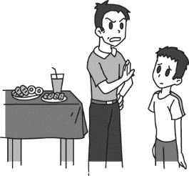 (B) 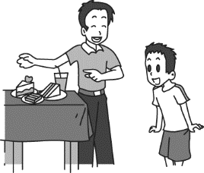 (C) 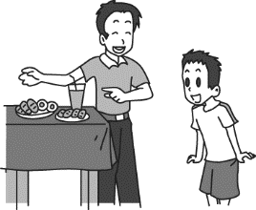

2. ( ) (A) 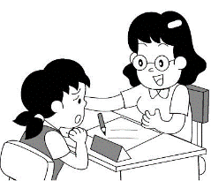 (B) 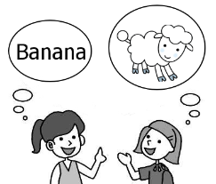 (C) 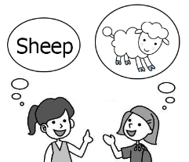

3. ( ) (A) 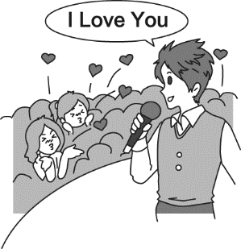 (B) 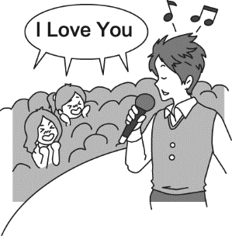 (C) 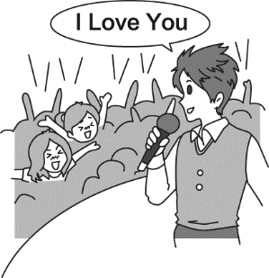

**二、基本問答：根據聽到的內容，選出一個最適合的回應或最適合的問句。（每題2分，共12分）**

|  |
| --- |
| (A) Oh, sorry, Mom. I won’t do that again. |
| (B) Doing trick-or-treating is interesting. |
| (C) You’re right. Let’s tell Andy to be a good boy. |

4. ( )

5. ( )

|  |
| --- |
| (A) Yes, he has been dead for years. |
| (B) Yes, he enjoys living by himself. |
| (C) Yes, he lost his family during an earthquake. |

6. ( )

|  |
| --- |
| (A) No, they run below ground. |
| (B) I know the cars that are out of date. |
| (C) Yes, they’re known for their green design. |

7. ( )

|  |
| --- |
| (A) Yes, Her oldest son is four years old. |
| (B) Yes, time flies. Jessica has been a mother for three years. |
| (C) Yes, Jessica just celebrated her twenty-third birthday. |

8. ( )

|  |
| --- |
| (A) She’s a cheerleader. |
| (B) My class leader did. |
| (C) We led the students to the classroom. |

9. ( )

|  |
| --- |
| (A) I’ll call her parents. |
| (B) I don’t know why she screamed. |
| (C) Tammy is the girl you’re talking about. |

**三、言談理解：根據聽到的內容，選出一個最適合的答案。（每題2分，共12分）**

10. ( )

|  |
| --- |
| (A) She ate something. |
| (B) She shared the rules with others. |
| (C) She touched the pictures. |

11.( )

|  |
| --- |
| (A) They should study hard and practice running hard. |
| (B) They will vote a new class leader after the exam. |
| (C) Their classroom is very clean. |

12.( )

|  |
| --- |
| (A) She wants him to put away the water she has boiled. |
| (B) She wants him to get some water to the bathroom for her. |
| (C) She wants him to make the fire on the oven stop burning. |

13.( )

|  |
| --- |
| (A) We need to know more about sharks. |
| (B) Sharks are terrible animals on Earth. |
| (C) Sharks kill a large quantity of people every year. |

14.( )

|  |
| --- |
| (A) The records of the world. |
| (B) The cold season in Japan and the USA. |
| (C) The winter activities. |

15.( )

|  |
| --- |
| (A) The glue is in the second drawer. |
| (B) The flashlight is in the top drawer. |
| (C) The scissors are in the second drawer. |

**第二部份:閱讀試題**

**四、單題：（每題2分，共54分）**

16.( ) We have only one Earth. Don’t you think we should do our best to the beautiful planet?　

|  |  |  |  |
| --- | --- | --- | --- |
| 1. protect | 1. hug | 1. adopt | 1. row |

17.( ) After the strong earthquake, many dead bodies were found in the .

|  |  |  |  |
| --- | --- | --- | --- |
| 1. drawer | 1. gas | 1. couch | 1. rubble |

18.( ) In my school days, I to English radio programs every day. That was how I learned English

at that time. **〔108.會考〕**

|  |  |  |  |
| --- | --- | --- | --- |
| 1. listen | 1. have listened | 1. used to listen | 1. was listening |

19.( ) Liz: How come the famous actress was taken a photo in the house on the hill without her knowledge?

Ben: The paparazzi（狗仔隊）used a to take her picture.

|  |  |  |  |
| --- | --- | --- | --- |
| 1. volcano | 1. drone | 1. package | 1. footprint |

20.( ) The new student has me lots of trouble. I’ll have to talk with his parents in person and see

what we can do to help him have good manners.

|  |  |  |  |
| --- | --- | --- | --- |
| 1. tested | 1. delivered | 1. caused | 1. noticed |

21.( ) The says, “Hand in your report today.”

|  |  |  |  |
| --- | --- | --- | --- |
| 1. blanket | 1. riddle | 1. notice | 1. blackboard |

22.( ) Look at the picture. The dog is sitting .**〔106.會考修訂〕**

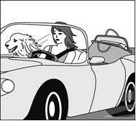

|  |  |  |  |
| --- | --- | --- | --- |
| 1. on the bag | 1. beside the woman | 1. between the woman | 1. inside the bag |

23.( ) One cold winter night, the apartment building began shaking badly and was in seconds.

|  |  |  |  |
| --- | --- | --- | --- |
| 1. tidied up | 1. put up | 1. knocked down | 1. set up |

24.( ) Look at the picture. The man is looking for money but does not notice that it is in the top .

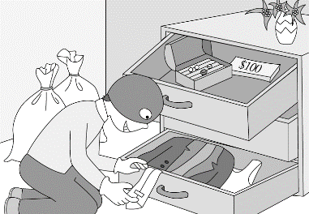

|  |  |  |  |
| --- | --- | --- | --- |
| 1. bag | 1. case | 1. vase | 1. drawer **〔101.基測〕** |

25.( ) Mike: Who is the 　　　 of the talent contest tonight? Ben: Kevin is.

|  |  |  |  |
| --- | --- | --- | --- |
| 1. trick | 1. host | 1. show | 1. talent |

26.( ) Gary is the best teacher I’ve ever known. No one 　　　 teaches so well. **〔100.基測Ⅰ〕**

|  |  |  |  |
| --- | --- | --- | --- |
| 1. other | 1. all | 1. others | 1. else |

27.( ) She kept writing about everything happened in her everyday life.

|  |  |  |  |
| --- | --- | --- | --- |
| 1. how | 1. what | 1. where | 1. who |

28.( ) Never 　　　 how much money you bring with you, or you’ll be in danger.

|  |  |  |  |
| --- | --- | --- | --- |
| 1. fill in | 1. turn into | 1. dress up | 1. show off |

29.( ) Do you know the girl to Joe is talking?

|  |  |  |  |
| --- | --- | --- | --- |
| 1. who | 1. whose | 1. whom | 1. that |

30.( ) Dad, smoking 　　　 your health. Isn’t it better for you to quit smoking?

|  |  |  |  |
| --- | --- | --- | --- |
| 1. copies | 1. affects | 1. gives | 1. repeats |

31.( ) Alice: Do you know Grandma is going to visit us? Willy: It’s next week.

She told me on the phone. And we’ll take her to the national park. **〔107.會考〕**

|  |  |  |  |
| --- | --- | --- | --- |
| 1. when | 1. where | 1. whether | 1. why |

32.( ) I was surprised to know from the newspaper yesterday flowers do not always smell sweet;

some can smell like dead fish. **〔102.基測〕**

|  |  |  |  |
| --- | --- | --- | --- |
| 1. that | 1. when | 1. where | 1. which |

33.( ) I think the road ends here; it won’t go any . Shouldn’t we turn back? **〔103.　會考〕**

|  |  |  |  |
| --- | --- | --- | --- |
| 1. closer | 1. farther | 1. faster | 1. longer |

34.( ) Jack isn’t a kind person because he thought of no one but .

|  |  |  |  |
| --- | --- | --- | --- |
| 1. himself | 1. his own | 1. him | 1. by oneself |

35.( ) I’m not sure he will stop feeling stressed out in a short time or not.

|  |  |  |  |
| --- | --- | --- | --- |
| 1. although | 1. if | 1. as long as | 1. as soon as |

36.( ) Last Saturday morning, we got up much than we usually .

|  |  |  |  |
| --- | --- | --- | --- |
| 1. earlier, do | 1. earlier, are | 1. more early, do | 1. more early, are |

37.( ) The weather rainy and cloudy in the last few days.

I hope the sun will come out soon. **〔106.會考〕**

|  |  |  |  |
| --- | --- | --- | --- |
| 1. has been | 1. had been | 1. will be | 1. would be |

38.( ) My parents have different hobbies. One enjoys baking; 　　　 enjoys taking pictures.

**〔105.會考〕**

|  |  |  |  |
| --- | --- | --- | --- |
| 1. another | 1. the next | 1. the other | 1. the second |

39.( ) When Sean came to Taiwan several years ago, 　　　 people knew about him.

But now he is a famous cook in Taiwan. **〔98.基測Ⅱ〕**

|  |  |  |  |
| --- | --- | --- | --- |
| 1. any | 1. few | 1. little | 1. most |

40.( ) Michelle Walden, 　　　 of the best basketball players in our school history, was called

“Flying Walden” because she could jump very high. **〔100.基測Ⅱ〕**

|  |  |  |  |
| --- | --- | --- | --- |
| 1. any | 1. each | 1. one | 1. who |

41.( ) “Are you dating anyone special today?” is a question that popular movie stars ______ in an interview.

**〔102.基測〕**

|  |  |  |  |
| --- | --- | --- | --- |
| 1. to be often asked | 1. are often asked | 1. being often asked | 1. who are often asked |

**五、題組：（每題1分，共20分）**

**(5-1)**

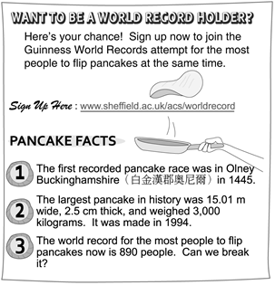

42.( ) Which is true about the largest pancake in history?

|  |
| --- |
| (A) It was 3.5 centimeters thick. |
| (B) It was less than 1,500 centimeters wide. |
| (C) It was heavier than 2,500 kilograms. |
| 1. It was made in 1445. |

43.( ) How many people should join the pancake race if they want to break the record of flipping pancakes?

|  |
| --- |
| (A) 888 |
| (B) 889 |
| (C) 890 |
| 1. 891 |

44.( ) What is the flyer（傳單）trying to get people to do?

|  |
| --- |
| (A) To break a world record together. |
| (B) To make the yummiest pancake in the world. |
| (C) To join a pancake race in Olney Buckinghamshire. |
| 1. To sign their names on the *Guinness World Records* book. |

**(5-2)**

*Look at the bar chart below.*

*It shows the number of students in each club at Green High School in 2014, 2015, and 2016.*

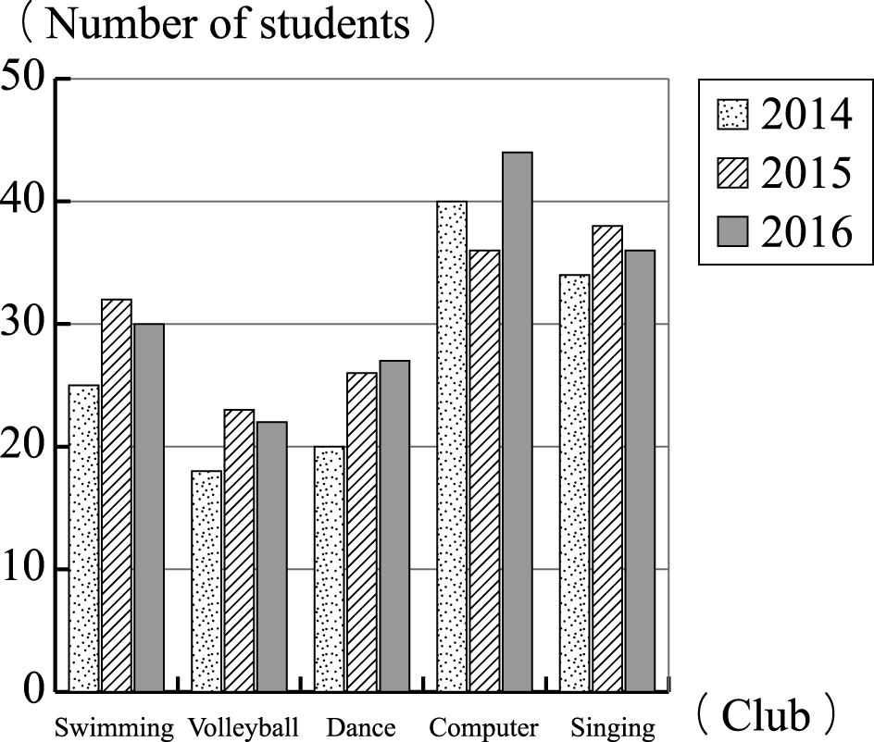

45.( ) Lolli is interested in singing and she is going to join the club. Which is true about the club?

|  |
| --- |
| (A) It was the most popular club in 2015. |
| (B) It has more and more members every year. |
| (C) It has more members in 2014 than in 2016. |
| 1. In 2014, it has two times the number of students of the dance club. |

|  |
| --- |
| Dad: Which club are you going to join, son?  Billy: I want to join the club which has the fewest members in the past years.  Dad: Why?  Billy: It’s my favorite sport. |

46.( )

Which club will Billy join?

|  |
| --- |
| (A) The swimming club. |
| (B) The volleyball club. |
| (C) The dance club. |
| 1. The computer club. |

47.( ) 　Which is NOT true according to（依據） the bar chart?

|  |
| --- |
| (A) The dance club has more and more members every year. |
| (B) The swimming club has more members in 2015 than in 2016. |
| (C) In 2016, the volleyball club has half the number of students of the computer club. |
| 1. The computer club has always been the most popular club in the past three years. |



**(5-3) Justin Bieber** is a singer from Canada. He was born on March 1, 1994. He is one hundred and seventy-five centimeters tall. He is interested in hockey, soccer and chess. He teaches himself to play the piano, drums, guitar, and trumpet. He becomes famous after he puts his videos on the Internet. In the beginning, people don’t pay too much attention to his videos, but he gets more and more attention in the end. His first single is “One Time” and his first full album is “My World 2.0.”

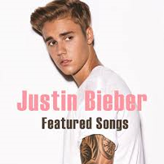

48.( ) 　What sports does Justin Bieber play?

|  |
| --- |
| (A) Tennis. |
| (B) Soccer. |
| (C) Baseball. |
| 1. Basketball. |

49.( ) How does Justin Bieber become famous?

|  |
| --- |
| (A) His dad is a superstar. |
| (B) He joins a singing class. |
| (C) He plays the violin well. |
| 1. He puts his videos on the Internet. |

50.( ) Which is true about Justin Bieber?

|  |
| --- |
| (A) He teaches himself to play the piano. |
| (B) His first single is “My World 2.0.” |
| (C) He comes from the USA. |
| 1. He is 165 cm tall. |

**(5-4)** *There are four new food shops near Billy’s house. Here are their ads.*

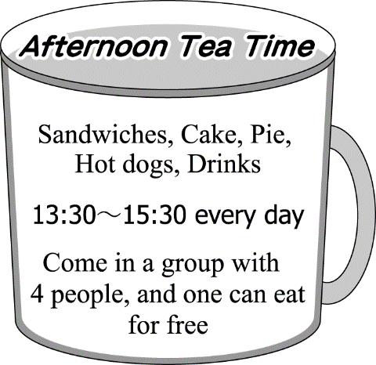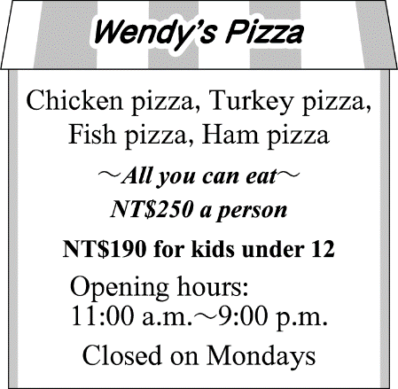

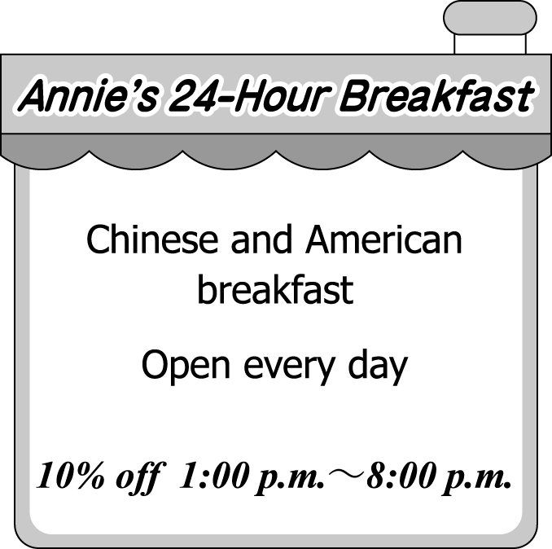 

51.( ) Today is Ellis’ eleventh birthday. Her parents take her and her 8-year-old brother to Wendy’s Pizza for

dinner. How much do Ellis’ parents pay?

|  |
| --- |
| (A) NT$1,000. |
| (B) NT$880. |
| (C) NT$750. |
| 1. NT$690. |

52.( ) 　Su goes to Afternoon Tea Time with Winx, May, and Lolli on Saturday afternoon.

They all order a cake and a drink. A cake is NT$55. A drink is NT$40. How much do they pay?

|  |
| --- |
| (A) NT$95. |
| (B) NT$190. |
| (C) NT$285. |
| 1. NT$380. |

53.( ) The Benson family go to “X” at 2:30 p.m. on Sunday. But “X” isn’t open. Which is “X”?

|  |
| --- |
| (A) Afternoon Tea Time. |
| (B) Wendy’s Pizza. |
| (C) Annie’s 24-Hour Breakfast. |
| 1. Susan’s Shop. |

**(5-5) Steve Jobs** was an American inventor. He lived from February 24, 1955 to October 5, 2011. He died of cancer at the age of 56. Jobs did something great for the personal computers, the smartphones, and high-quality tablet computers. When he died, it was in the news all over the world.

　　Jobs is best known for working for the company Apple Incorporated. Along with his partner Steve Wozniak, Jobs began one of the earliest lines of successful personal computers in the late 1970s. Apple’s computers keep being popular today. He is also famous for making the iPod, the iPhone, and the iPad. The iPod made digital music very popular. The iPhone was a simple smartphone, and it could also be used as an iPod. The iPad was one of the world’s first tablet computers. All of the products were made to be easy to use and beautifully designed. Besides, Jobs was the founder of the animation studio Pixar. It made many popular movies, like Toy Story and Finding Nemo. He also donated some of his money to Africa. Jobs was a very important person in many ways, and his life affected people around the world.

 

54.( ) What can the iPod be used to do?

|  |
| --- |
| (A) Make an animation movie. |
| (B) Listen to digital music. |
| (C) Make phone calls. |
| 1. Work on reports or homework. |

55.( ) Which is NOT true about the iPad?

|  |
| --- |
| (A) It was made by Steve Jobs. |
| (B) It was a tablet computer. |
| (C) It was easy to use. |
| 1. It was one of the earliest lines of successful personal computers. |

56.( ) What can we learn about Steve Jobs?

|  |
| --- |
| (A) He did not get along well with his partner in his company. |
| (B) He founded（創立）the animation studio Pixar, but he failed to make any popular movies. |
| (C) He cared a lot about people in Africa. |
| 1. His death was not surprising to people around the world at all. |

**(5-6)**

Each country has her national flag, and usually there is a story behind each national flag. The national flag of the United Kingdom tells an interesting story, too.

　　The UK has four parts. They are England, Wales, Scotland, and Northern Ireland. They all have their own flags. When Wales became part of England in 1542, the flag of England was the one used　—　nothing was changed. However, in 1603, when Scotland joined England to become a new country, the two national flags were put together to have a new flag. The last member, Ireland, joined the kingdom in 1801, and it was in that year that the modern flag we see today appeared. In 1992, however, parts of Ireland left the kingdom to become a new country. It also started to use its own flag.

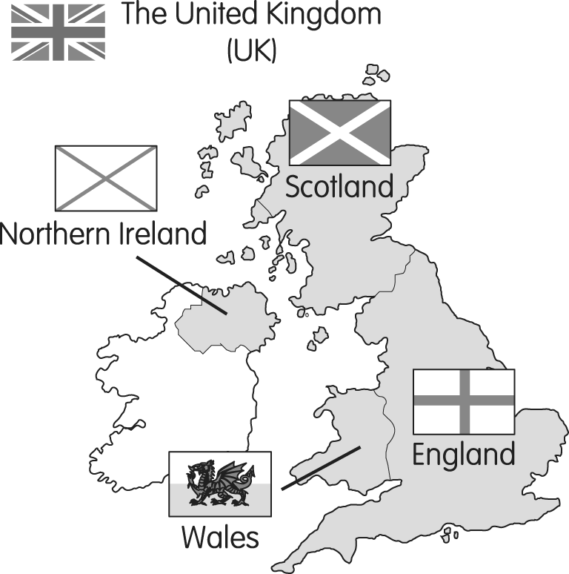

57.( ) Which is true about how the UK got its national flag?

|  |
| --- |
| (A) 104-4-2(國旗) |
| (B) 104-4-3(國旗) |
| (C) 104-4-4(國旗) |
| 1. 104-4-5(國旗) |

58.( ) Which is NOT true?

|  |
| --- |
| (A) The whole Ireland still belongs to the UK. |
| (B) The UK got the modern flag in 1801. |
| (C) Scotland became part of the UK in 1603. |
| 1. When Wales became part of England in 1542, it still used the flag of England. |

59.( ) Which is said about Ireland?

|  |
| --- |
| (A) It has used the national flag of the UK since it joined the kingdom. |
| (B) It was the first member to join the United Kingdom. |
| (C) The old Ireland flag can still be seen in today’s national flag of the UK. |
| 1. Part of it became a new country, and part of Scotland did, too. |